Name: Omar Mohamed Mostafa Ali ELNAEB

*B.N/3*

*TOPIC: Artificial intelligence*

*Application brief: Artificial intelligence, defined as intelligence exhibited by machines, has many applications in today's society. More specifically, it is Weak AI, the form of AI where programs are developed to perform specific tasks, that is being utilized for a wide range of activities including medical diagnosis, electronic trading platforms, robot control, and remote sensing. AI has been used to develop and advance numerous fields and industries, including finance, healthcare, education, transportation, and more.*

# 

### SCREENSHOTS:

# Deep learning vs. machine learning

* **main page**
* **meaning of artificial intelligence**
* **Artificial intelligence applications**
* **History of artificial intelligence**
* **Deep learning vs. machine learning**

**Deep learning vs. machine learning 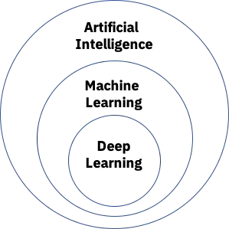 Since deep learning and machine learning tend to be used interchangeably, it’s worth noting the nuances between the two. As mentioned above, both deep learning and machine learning are sub-fields of artificial intelligence, and deep learning is actually a sub-field of machine learning. Visual Representation of how AI, ML and DL relate to one another Deep learning is actually comprised of neural networks. “Deep” in deep learning refers to a neural network comprised of more than three layers—which would be inclusive of the inputs and the output—can be considered a deep learning algorithm. This is generally represented using the following diagram:**

# artificial intelligence main page

## main page

## meaning of artificial intelligence

## Artificial intelligence applications

## History of artificial intelligence

## Deep learning vs. machine learning

## [artificial-intelligence](https://www.ibm.com/cloud/learn/what-is-artificial-intelligence#toc-types-of-a-qfpGa56l)

## THIS is the main page of artificial intelligence

*Source code:*

<Html>

<Body>

<h1>artificial intelligence main page</h1>

<h2><links :></h2.>

<ul>

    <li><a href="main padge.html">main page</a</li>

    <li><a href="meaning of artificial intelligence.html">meaning of artificial intelligence </a></li>

    <li><a href="Artificial intelligence applications.html">Artificial intelligence applications</a></li>

    <li><a href="History of artificial intelligence.html">History of artificial intelligence</a></li>

    <li><a href="Deep learning vs. machine learning.html">Deep learning vs. machine learning</a></li>

    <li><a href="https://www.ibm.com/cloud/learn/what-is-artificial-intelligence#toc-types-of-a-qfpGa56l">artificial-intelligence</a></li>

</ul>

THIS is the main page of artificial intelligence

</body>

</html>